Installing ESU using Powershell

- Acquire a copy of the Powershell script, it can be found at the following locations:
- \\CAHNRS-Files\Shares\CIT.General\ESU Script
- \\cit-distribute\scripts
- On the machine that you are going to install the script on, open PowerShell with Administrator access.
- If using PowerShell ISE then click on file open and select the ESU script, you should see the following:
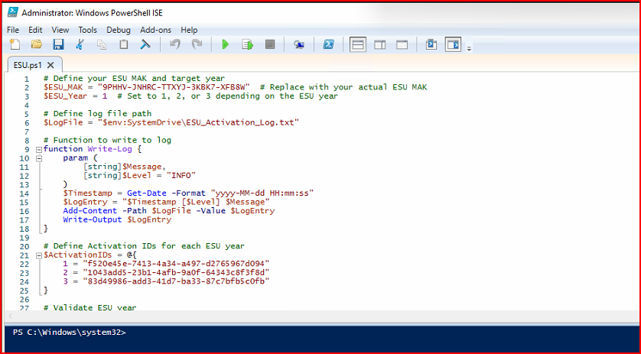

- If using regular Powershell you should see a screen like below, including the result:
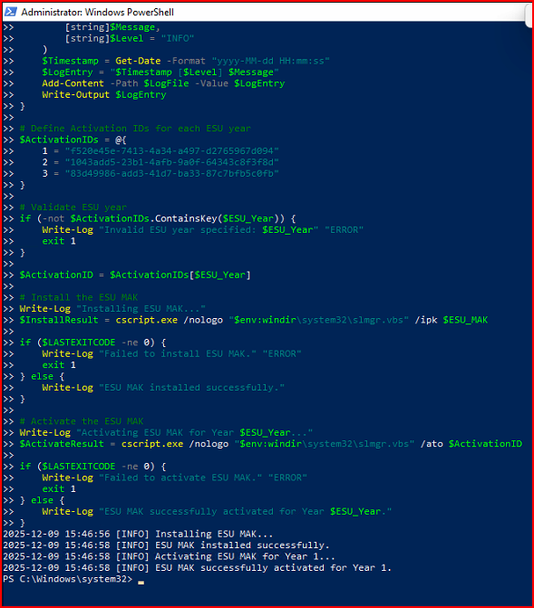

As you can see, when you run the script, you should see a result that the ESU MAK was successfully activated for 1 year.

