Creating a new file share

For this example, the share will be “CIT Example”
Create new share with 150GB quota to be used by our group for training.
The first thing you will do is navigate to your jump box VM on your machine and connect the VPN.
The you will remote desktop into cit-jump-fs.ad.wsu.edu using your Tier1Hi account.
- Create the groups for your new share using defaults
  - Open ADUC and Navigate to WSU\CAHNRS\Tier 2\Groups\Storage
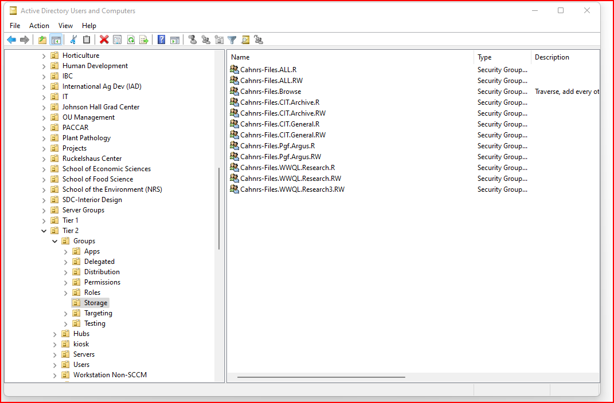
  - Create both a read group and read/write group for each folder, (make sure to make your groups a member of CAHNRS-Files.browse)
    - Cahnrs-Files.CIT.Example.R – Read Only
    - Cahnrs-Files.CIT.Example.RW – Do not check Full Control
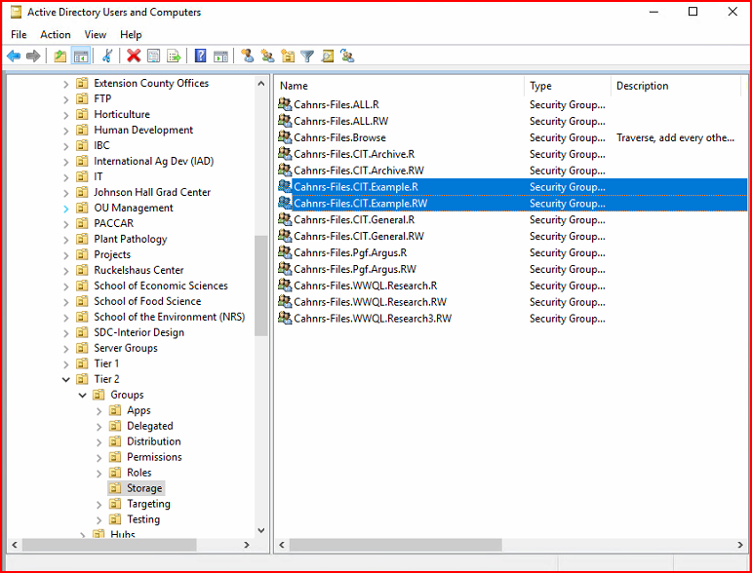
- Add users to the groups if you have a list. Or this can be done at a later date if you don’t have names yet

- Create the folder for your new share: Open File Explorer and Navigate to \\cahnrs-files\shares\
  - Create the folder CIT.Example

- Add the groups you created to the permissions of your new share.
  - Right-click the folder you just created, click on Properties
  - Add the RW and R group you just created to the share
  - Add the 2 groups you just created to the group Cahnrs.Files.Browse – (image 2 below)
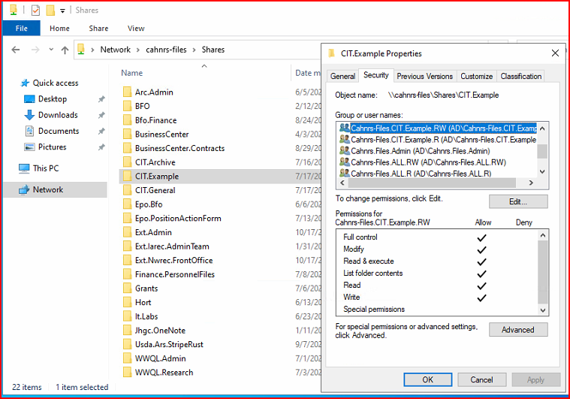
Image 2
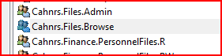

- Adjust the quota of the new share – not necessary if 100GB
  - Open File Server Resource Manager on cit-jump-fs
  - Right-click on File Server Resource Manager(Local) 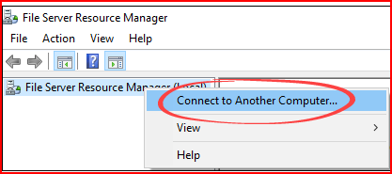
  - Connect to cahnrs-files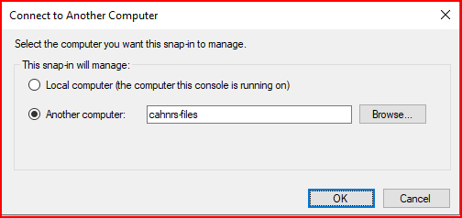
  - Expand the “Quota Management” > “Quotas”
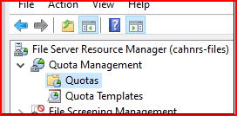

  - Double-click the CIT.Example quota to customize the limit, which for this example is 150GB
.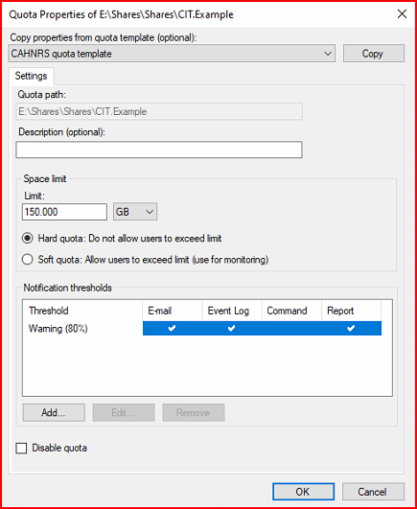
  - Hit Ok and you are done.
  - Wait approximately 5 minutes and verify your new share is listed under \\CAHNRS-Files\Shares\

Scripting that needs to be done at this time to resolve new shares not showing up in the list.
While still on the server cit-jump-fs, open a regular Powershell Windows – you do not need Administrator.
Then you will copy and paste the following command:
Repair-CITFileshare "\\cahnrs-files\shares\CIT.Sharename"
This will repair the permissions issue and allow the folder to show up to all the users in your groups you created.

After you have finished created the share, send an email to cit.systems@wsu.edu with the changelog of the information about the share your created including the quota information, path, and owner so that it can be invoiced and billed.

